# CPT_Logo_Manual.jpg Personalizing SharePoint

**Lab Time**: 60 minutes

**Lab Overview:** In this lab you will learn how to engage notification tools in SharePoint to stay informed about changing content. You will also explore personalizing your SharePoint experience using personal page views, personal list views, and regional settings. Lastly you will learn to find and revisit important content using SharePoint Search as well as Tags and Notes.

## Exercise 1: Subscribing to Alerts and RSS Feeds

In this exercise you will practice subscribing to SharePoint for notification of content additions and changes.

1. Log into your site collection using the account **Janice Galvin**.
2. Using Internet Explorer, browse to the URL of the SharePoint site collection you were provided to use when working on the hands on labs in this course.
3. When prompted to login, enter [[AD-DOMAIN]]\janice in the **User Name** field and click **OK**. Use the password specified in the *Hands-On Lab Overview* document provided in the student manual.

**Note**: If you are not prompted to login & if you are logged in as another user, use the Welcome Menu to logout and login as a different user.

1. Navigate to the Products subsite by clicking the **Products** link in the Top Navigation Bar.
2. Using the Welcome Menu in the upper right corner of the page select **My Settings**, then click on the **My Alerts** hyperlink in the toolbar of links:

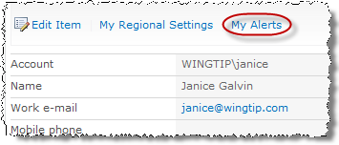

1. Add an alert for the Product site's Announcements list:
2. Click the **Add Alert** link at the top of the list of alerts:

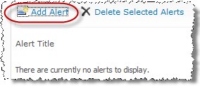

1. Click the radio button for the **Announcements** list, then click **Next**:
2. Fill in the new alert's properties as follows:

**Alert Title:** Products Site Announcements List New Items

**Delivery Method:** E-mail

**Change Type:** New items are added

**Send Alerts for These Changes:** Anything changes

**When to Send Alerts:** Send a weekly summary - Friday 8:00am

1. Click **OK** to complete creation of the new alert and verify it is now listed in the user’s My Alerts page. You may need to refresh the page to see the new alert.
2. Subscribe Mike Sullivan to an alert on the Employee Information folder of the Shared Documents document library.
3. Navigate to the **Shared Documents** document library by clicking the library's link in the Quick Launch Bar.
4. Authenticate into the library as Mike Sullivan using the **Welcome Menu** in the top right corner and select **Sign in as Different User** and enter [[AD-DOMAIN]]\michael for the user name and click **OK**.
5. Check the checkbox box for the **Employee Information** folder and click the **View Properties** button in the **Manage** group in the **Library Tools »** **Documents** tab in the ribbon.

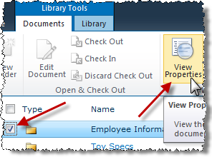

1. In the resultant pop-up dialog box of the folder properties, click the **Alert Me** link in the **Actions** group of the **View** tab in the ribbon.
2. Fill in the new alert's properties as follows:

**Alert Title:** Products SD Mfg Docs Folder

**Delivery Method:** E-mail

**Change Type:** All Changes

**Send Alerts for These Changes:** Someone else changes a document

**When to Send Alerts:** Send notifications immediately

1. Click **OK** to complete creation of the new alert then verify it exists in Michael’s **My Settings** » **My Alerts**
2. Navigate to the home page of the **Wingtip Team Products Site** via your preferred method.
3. Authenticate into the library as Janice Galvin using the **Welcome Menu** in the top right corner and select **Sign in as Different User** and enter [[AD-DOMAIN]]\janice for the user name and click **OK**.
4. Subscribe Janice to the RSS Feed of the Calendar list:
5. Navigate to the **Calendar** list by clicking the list's link in the Quick Launch Bar.
6. Click on the **RSS Feed** button in the **Share & Track** group of the **Calendar Tools » Calendar** ribbon:

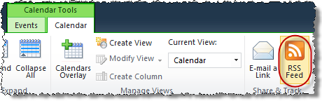

**Note**: The following experience my differ on a student-by-student basis depending on the configuration and version of your browser.

1. From the RSS preview page, click on the hyperlink in the header to **Subscribe to this feed.**

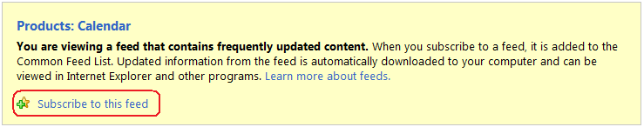

1. In the resulting **Subscribe to this feed** pop-up dialog box produced by Internet Explorer, the default RSS Feed Reader application, keep all defaults and click **Subscribe**.
2. Return to the Calendar list on the Products site by clicking the **Products:Calendar** feed title hyperlink.
3. Click on the **Favorites** button in Internet Explorer's toolbar, then click into the **Feeds** tab and verify that **Products:Calendar** now appears as a subscription.
4. Close the Favorites pane.

In this exercise you learned to subscribe for Alerts and RSS Feeds in SharePoint.

## Exercise 2: Create Personal Views

In this exercise you will explore the process of creating a personal view of a SharePoint web page as well as a document library.

1. Log into your site collection using the account **Janice Galvin**.
2. Using Internet Explorer, browse to the URL of the SharePoint site collection you were provided to use when working on the hands on labs in this course.
3. When prompted to login, enter [[AD-DOMAIN]]\janice in the **User Name** field and click **OK**. Use the password specified in the *Hands-On Lab Overview* document provided in the student manual.
4. The **Wingtip Team Site** site is a Team site which now includes the Site Pages library. This library, a wiki library, does not support personalization. Therefore you will need to go to a traditional Web Part Page. All SharePoint sites have a default Web Part Page which can be personalized. To get to this page, do the following:
5. Once on the Products site, look at the URL in the browser.
6. Remove the /SitePages/home.aspx from the URL and replace it with default.aspx.
7. You should now be in the traditional SharePoint Web Part Page experience:

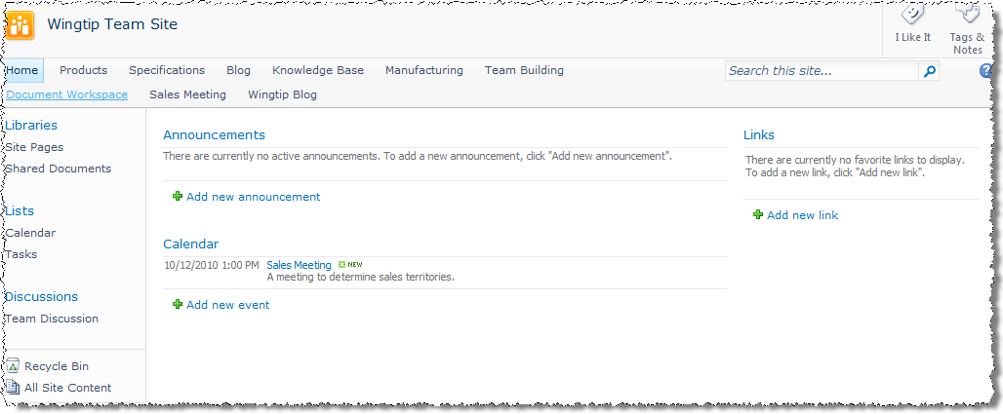

1. Edit Janice’s personal view of the Web Part Page:
2. Using the Welcome Menu, select Personalize this Page:

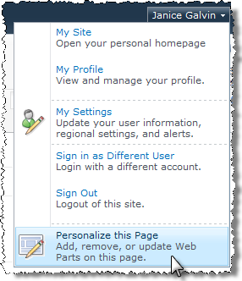

1. Notice the informational banner indicating you are editing Janice’s Personal View of the page:

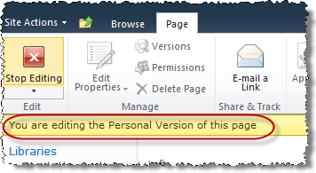

1. Hover over the **Image Viewer** Web Part in the to click the drop-down arrow and select **Close** from the drop-down menu to close this Web Part in Student's personal view.

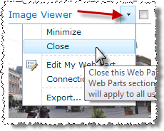

1. Click the **Add a Web Part** hyperlink in the **Left** zone then scroll down to highlight the **Social Collaboration** category of Web Parts and select the **Site Users** Web Part. Click **Add** to add the Web Part to the page.

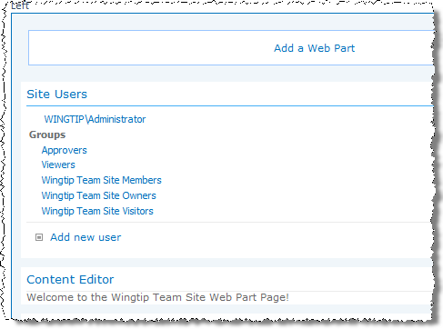

1. Click the **Stop Editing** button in the **Edit** group of the **Page** tab in the ribbon to complete your edits.
2. Verify that the new personal design of the Web Part page appears for Janice.
3. View the Web Part Page as another user:
4. Authenticate into the library as Michael Sullivan using the **Welcome Menu** in the top right corner and select **Sign in as Different User** and enter [[AD-DOMAIN]]\michael for the user name and click **OK**.
5. Notice that the **Image Viewer Web Part** reappears for Michael and that the **Site Users Web Part** is not present.
6. Authenticate into the library as Janice Galvin using the **Welcome Menu** in the top right corner and select **Sign in as Different User** and enter [[AD-DOMAIN]]\janice for the user name and click **OK**.
7. Notice that Janice’s personal view of the Web Part page appears automatically.
8. Flip between Personal View and Shared View as Janice:
9. Use the **Welcome Menu** to select the **Show Shared View** to display the public view of the Web Part page.
10. Notice that the **Image Viewer Web Part** reappears for Janice and that the **Site Users Web Part** is not present. Janice does NOT receive a combination of both the Personal View additions and the public Web Parts.
11. Use the **Welcome Menu** to select the **Show Personal View** to display Janice’s personal view of the Web Part page.
12. Reset Janice’s Personal View of the page:
13. Use the **Welcome Menu** to select the **Reset Page Content** to reset all layout and Web Parts to the default (Shared View) version of the page, thereby making Janice’s Personal View look identical to the Shared View of the page.
14. Click **OK** to the Web page warning that all of Janice’s personalization will be lost.

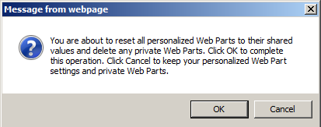

1. Use the **Welcome Menu** to select the **Show Shared View** is an option, meaning that while Janice’s Personal View now mimics the Shared View of the page, it is STILL Student's Personal View.
2. Notice that the **Image Viewer Web Part** reappears **Site Users Web Part** is not present.
3. Visit the **Products** site's **Site Pages** library using the library's link in the Quick Launch bar.
4. Create a Personal View of the Site Pages library:
5. Click on the **Create View** button in the **Manage Views** group of the **Library Tools » Library** tab in the ribbon.

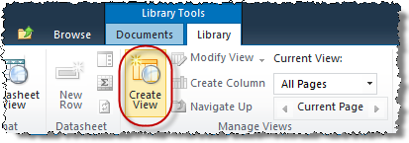

1. Click on the **Standard View** button or title under the **Choose View Format** header on the **Create View** page. Use the following to create the new view and click **OK**:

**Name:** Janice’s Personal View

**Audience:** Create a Personal View

**Columns:** Check only the following: Edit (link to Edit item) - Position 1; Name (linked to document) - Position 2; Check In Comment - Position 3

**Sort:** First Column = Name (linked to document)

**Mobile:** **Clear** Enable this view for mobile access

1. Verify the correct columns appear in the correct order on the view:

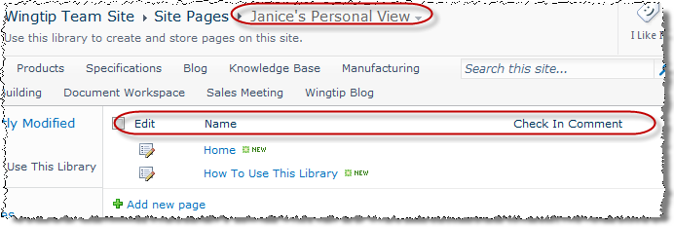

1. Return to the default public view of the library by selecting the **All Pages** view from the drop down menu of the **Current View** option in the **Manage Views** group of the **Library Tools » Library tab** in the ribbon. Note that **Janice’s Personal View** is now one of the named view choices in the drop down.
2. Visit the Site Pages library as another user.
3. Authenticate into the library as Michael Sullivan using the **Welcome Menu** in the top right corner and select **Sign in as Different User** and enter [[AD-DOMAIN]]\michael for the user name and click **OK**.
4. Explore the drop down menu of the **Current View** option in the **Manage Views** group of the **Library Tools » Library tab** in the ribbon. Note that Janice’s Personal View is not available to Michael Sullivan.
5. Authenticate into the library as Janice Galvin using the **Welcome Menu** in the top right corner and select **Sign in as Different User** and enter [[AD-DOMAIN]]\janice for the user name and click **OK**.

In this exercise you learned to invoke personal views.

## Exercise 3: Searching and Tagging

In this exercise you will perform a search in SharePoint for specific content and user information. You will also learn to use tagging to mark important information.

1. Navigate to the Wingtip Team Site using the method of choice.
2. Perform a simple search for content:
3. Locate the search textbox in the upper right corner of the page:

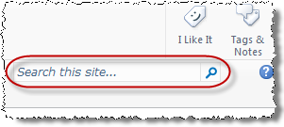

1. Type **knowledge** into the search textbox, then click on the magnifying glass icon to engage the search engine.
2. On the **Site Search Results** page, notice the title, icon and URL information of each result and how the search engine sorts by relevance as a default, which put the link to the actual **Knowledge Base** site as the first item in the results listing:

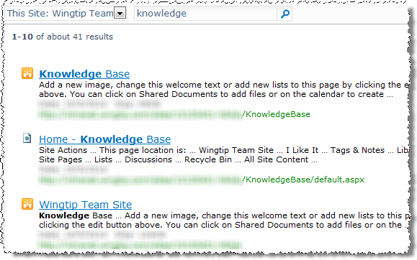

1. Click on either the **Knowledge Base** site title hyperlink or the green URL hyperlink to navigate directly to the Knowledge Base site.
2. Return to the home page of the Wingtip Team Site via your preferred method.
3. Perform an advanced search for content:
4. Navigate to the Wingtip enterprise search page by clicking the **Search** site's hyperlink in the top link bar of the Wingtip Team Site.

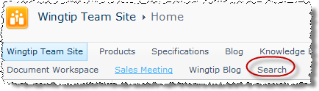

1. From the **All Sites** tab, click on the **Advanced** hyperlink to the right of the search textbox:

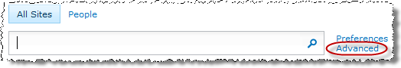

1. Examine the options on the **Advanced Search** page under the **Find documents that have...** heading.
2. Perform an advanced search for all documents authored by Janice Galvin by leaving the fields in the **Find documents that have...** heading blank and instead defining a property restriction in the **Add property restrictions...** heading. Specifically, enter the following values into the **Where the Property...** line:

**(Pick Property) drop-down:** Author

**Operand drop-down:** Contains (default)

**Textbox:** Janice

**Multiplier:** And (default)

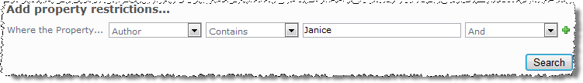

1. Browse the search results and click on a document or blog post authored by Janice.
2. Navigate back to the home page of the Wingtip Team Site. This can be tricky from the search results as there is no Top Navigation Bar or Quick Launch bar. One way is to just type the URL in or open up a Web page in the search results and use one of the options you’ve learned.
3. Perform a simple People search:
4. Authenticate into the library as Michael Sullivan using the **Welcome Menu** in the top right corner and select **Sign in as Different User** and enter [[AD-DOMAIN]]\michael for the user name and click **OK**.
5. Navigate to the Wingtip enterprise search page by clicking the **Search** site's hyperlink in the top link bar of the Wingtip Team Site.
6. Click on the People tab above the search textbox.
7. Type **Ken** into the search textbox then click on the magnifying glass icon to execute the search.
8. You will see a single hit for Ken Sanchez and information entered into his profile in a previous lab:

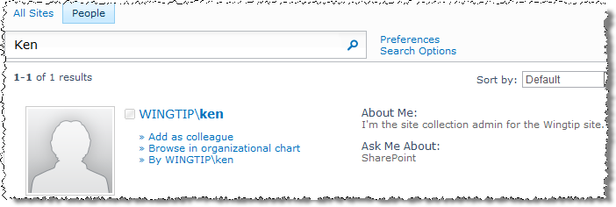

1. In the list of hyperlinks to the right of the thumbnail on the first result, hover over the **» By WINGTIP\ken** link to see a brief list of documents and titles authored by Ken:

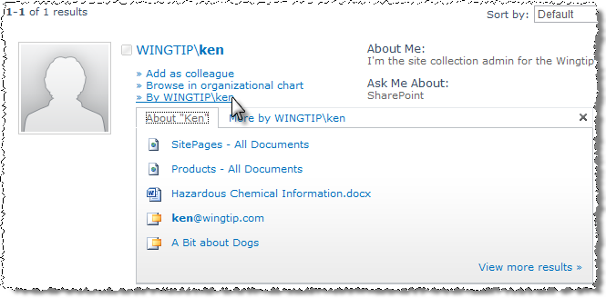

1. From the same list of hyperlinks to the right of the thumbnail click the WINTIP\ken link to navigate to the public view of the profile page on **Ken’s My Site** site.

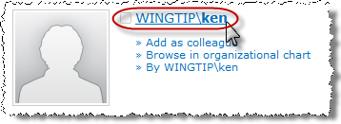

1. Navigate back to the home page of the Wingtip Team Site. This can be tricky from the search results as there is no Top Navigation Bar or Quick Launch bar. One way is to just type the URL in or open up a Web page in the search results and use one of the options you’ve learned.
2. Tag an item in the Announcements list with the predefined "I Like It" tag:
3. Using the **All Site Content** link in the Quick Launch Bar, navigate to the **Announcements** list.
4. Check the selection box for the first item in the Announcements list then click the **I Like It** button in the **Tags and Notes** group in the **List Tools » Items** tab in the ribbon.

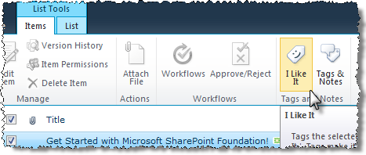

1. Using the **Welcome Menu**, select **My Profile** then click the **Tags and Notes** tab below the thumbnail.
2. Verify that the Announcement item you tagged appears under the **Activities For: …**section on the right.

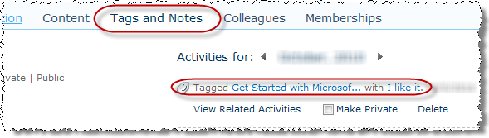

1. Click the small **I Like It** hyperlink in the description of the tagged item.
2. Note that you can easily share your new tag with other users by adding it to your **My Newsfeed** or **Ask Me About** section of your **My Profile**.
3. Navigate back to the home page of the Wingtip Team Site. This can be tricky from the search results as there is no Top Navigation Bar or Quick Launch bar. One way is to just type the URL in or open up a Web page in the search results and use one of the options you’ve learned.
4. Navigate to the Products subsite.
5. Tag a document in the Shared Documents library with a custom tag:
6. Using the **All Site Content** link in the Quick Launch Bar, navigate to the **Shared Documents** library.
7. Click into the **Toy Specs** folder and check the selection box for the **ElectronicsSpec** document.
8. Click the **Tags & Notes** button from the **Tags and Notes** group in the **Library Tools » Documents** tab in the ribbon.
9. In the **Shared Documents - ElectronicSpec.docx** dialog box, enter **Important Spec Docs** into the textbox below the My Tags hyperlink and click **Save**:

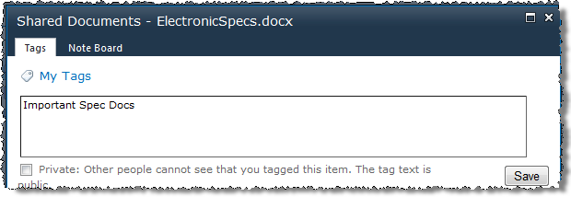

1. Click the new tag's hyperlink **Important Spec Docs** that appears under the heading **Suggested Tags** at the bottom of the **Shared Documents - ElectronicsSpec.docx** dialog box.
2. Click on the **Go to Tag Profile for Important Spec Docs** link that appears to navigate to the tag's details in the **My Profile** page.
3. Note that you can easily share your new tag with other users by adding it to your **My Newsfeed** or **Ask Me About** section of your My Profile.
4. Navigate back to the home page of the Wingtip Team Site. This can be tricky from the search results as there is no Top Navigation Bar or Quick Launch bar. One way is to just type the URL in or open up a Web page in the search results and use one of the options you’ve learned.
5. Navigate to the Products subsite.
6. Add notes to a document in the Shared Documents library with a custom tag:
7. Using the **All Site Content** link in the Quick Launch Bar, navigate to the **Shared Documents** library.
8. Click into the **Toy Specs** folder and check the selection box for the **ElectronicsSpec** document.
9. Click the **Tags & Notes** button from the **Tags and Notes** group in the **Library Tools » Documents** tab in the ribbon.
10. In the **Shared Documents - MechanicalSpec.docx** dialog box, click the **Note Board** tab.

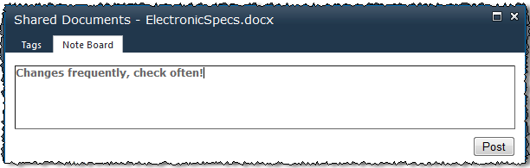

1. Enter **Changes frequently, check often!** into the textbox hyperlink and click **Post**.
2. Verify that your notes now appear underneath the **Previous | Next** links.
3. Using the **Welcome Menu**, select **My Profile** then click the **Tags and Notes** tab below the thumbnail.
4. Read all notes and identify tagged items from your My Profile pages.

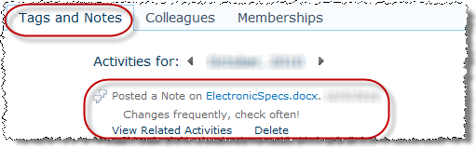

In this exercise you practiced searching and using tags.